Formation of Urine KEY
SI-Fall 2025

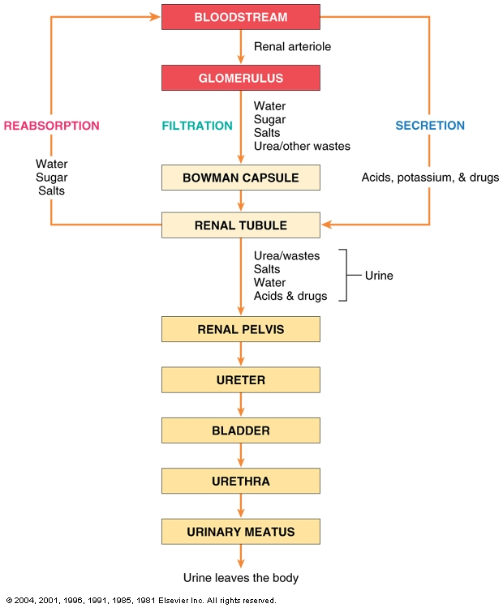

- Which of the following would be expected to trigger a decrease in the secretion of ADH?
  - Ingestion of a large quantity of pure water
  - Sweating
  - Hemorrhage
  - A decrease in mean arterial pressure
  - Both a and c

- Which of the following would be expected to trigger a decrease in the secretion of renin?
  - A decrease in the mean arterial pressure
  - A decrease in the pressure inside the afferent arteriole
  - A decrease in the activity of renal sympathetic nerves
  - A decrease in the concentration of sodium chloride in tubular fluid
  - A decrease in GFR

- An increase in mean arterial pressure stimulates which of the following?
  - ADH release
  - Angiotensin II production
  - Aldosterone release
  - Renin release
  - Increased water excretion in urine

- Most solutes and water are reabsorbed in the (proximal tubule/distal and collecting duct).

- Potassium secretion is (stimulated/inhibited) by aldosterone.

- The kidneys can excrete urine that is pure water. (true/false)

- Which of the following tends to promote an increase in sodium excretion?
  - An increase in the GFR
  - An increase in plasma renin concentration
  - An increase in the secretion of atrial natriuretic peptide
  - Both a and c
  - All of the above

- Epithelial cells of the descending limb of the nephron loop actively transport solutes from tubular fluid to the surrounding peritubular space. (true/false)

- Urine flow rate increases as the plasma ADH level (increases/decreases).

- There is no limit to the amount of hydrogen ions the kidneys can excrete. (true/false)

