Ovulation & Menstruation
SI-Fall 2025

Ovulation
1. List the associated cell types with the stages of follicular development.

2. Days 1-14, period of vesicular follicle growth is ______________phase.

3. Days 14-29, period of corpus luteum activity is ________________ phase.

- Which hormone is primarily responsible for triggering ovulation?
A) Progesterone
B) LH (luteinizing hormone)
C) Estrogen
D) FSH (follicle-stimulating hormone)
- What marks the end of the follicular phase?
A) Formation of the corpus luteum
B) Menstruation
C) Ovulation
D) Rise in progesterone
- Which structure produces progesterone during the luteal phase?
A) The developing follicle
B) The corpus luteum
C) The hypothalamus
D) The endometrium
- What happens if the released egg is not fertilized?
A) The corpus luteum persists
B) Progesterone levels remain high
C) The corpus luteum degenerates
D) Estrogen levels rise
- During which phase does the endometrial lining of the uterus thicken in preparation for potential implantation?
A) Follicular phase
B) Ovulation
C) Luteal phase
D) Menstrual phase

Menstrual Cycle
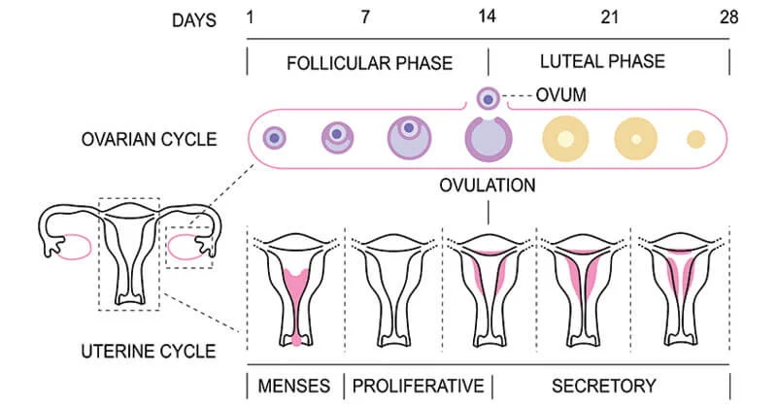

- Menstrual phase: days ___________
_________hormone at lowest level
Gonadotropin begins to _____________

__________ functionalis detaches from uterine wall and shed.

- Proliferative phase: days ________
Rising/falling estrogen levels generate new layer
Cervical mucus thins/thickens.

- Secretory phase
Phase that is the most consistent in duration. T or F?
Endometrium prepares__________ to implant.
__________levels fall if fertilization does not occur.

