Ovulation & Menstruation Key

Ovulation & Menstruation
SI-Fall 2025

Ovulation
1. List the associated cell types with the stages of follicular development.

2. Days 1-14, period of vesicular follicle growth is follicular phase.

3. Days 14-29, period of corpus luteum activity is luteal phase.

- Which hormone is primarily responsible for triggering ovulation?
A) Progesterone
B) LH (luteinizing hormone)
C) Estrogen
D) FSH (follicle-stimulating hormone)
- What marks the end of the follicular phase?
A) Formation of the corpus luteum
B) Menstruation
C) Ovulation
D) Rise in progesterone
- Which structure produces progesterone during the luteal phase?
A) The developing follicle
B) The corpus luteum
C) The hypothalamus
D) The endometrium
- What happens if the released egg is not fertilized?
A) The corpus luteum persists
B) Progesterone levels remain high
C) Estrogen levels rise
D) The corpus luteum degenerates

- During which phase does the endometrial lining of the uterus thicken in preparation for potential implantation?
A) luteal phase
B) Ovulation
C) primordial phase
D) Menstrual phase

Menstrual Cycle
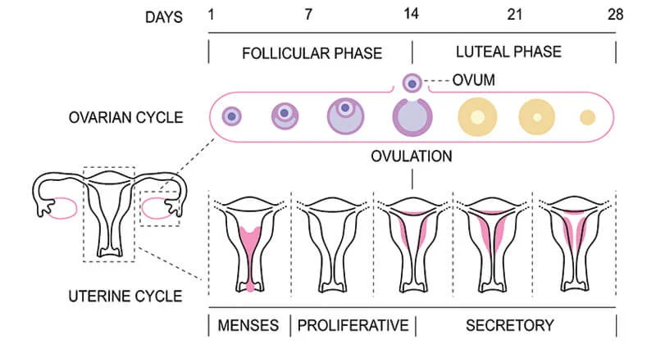

- Menstrual phase: days 1-5
Ovarian hormone at lowest level
Gonadotropin begins to rise
Stratum functionalis detaches from uterine wall and shed.

- Proliferative phase: days 6-14
Rising/falling estrogen levels generate new layer
Cervical mucus thins/thickens.

- Secretory phase
Phase that is the most consistent in duration. T or F?
Endometrium prepares embryo to implant.
Progesterone levels fall if fertilization does not occur.

